
Company
Logotype

Cone Beam Computed Tomography- Report



Porur Dental X-rays & CBCT

Patient Name : Mrs. Baghyalakshmi | Date of Report : 04.11.2025
Age/ Gender : 64 years/ Female | Region of Interest : CBCT Mandible
Referring doctor: Clove Dental | Indication : Assessment of 35, 37
Clinical Notes: Nil
PATIENT INFORMATION

CBCT- Mandible provided
CBCT – IMAGE DETAILS

RADIOGRAPHIC INTERPRETATION

- In relation to 35 and 37, hyperdense restorative material involving the crown and extending into the root canal upto the apical third is evident.
- In relation to 37, in the periapical region of the mesial root, presence of an irregular hypodense region measuring 5.22 x 2.62 x 3.13 mm in dimension is evident. In relation to the periapical aspect of the distal root, there are small spherical hyperdense structures suggestive of retained restorative material.

RADIOGRAPHIC IMPRESSION

- Root canal treated tooth: 35
- Root canal treated with periapical pathology (retained periapical restorative material): 37

Kindly correlate with clinical findings


IMAGES FOR REFERENCE

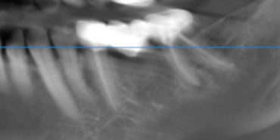

3-DIMENSIONAL VIEW

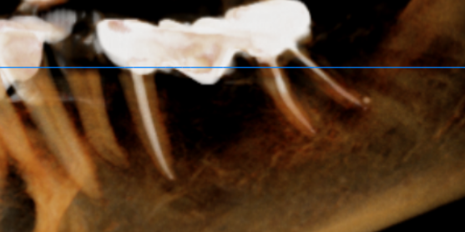

Sagittal Section | 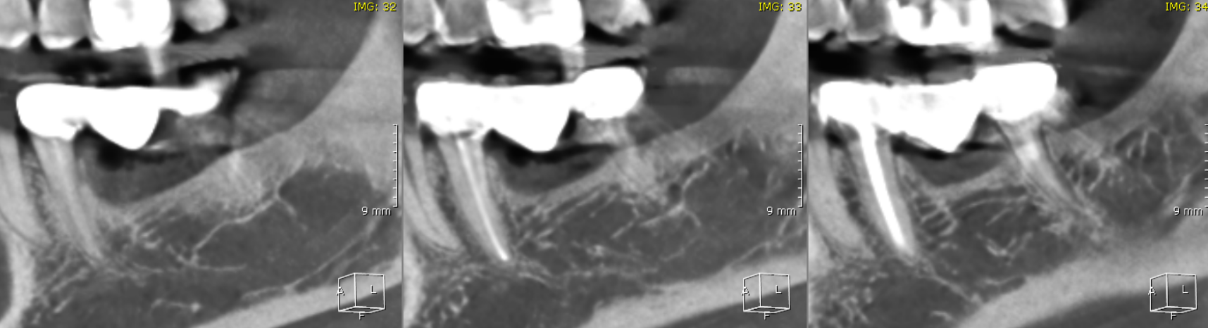  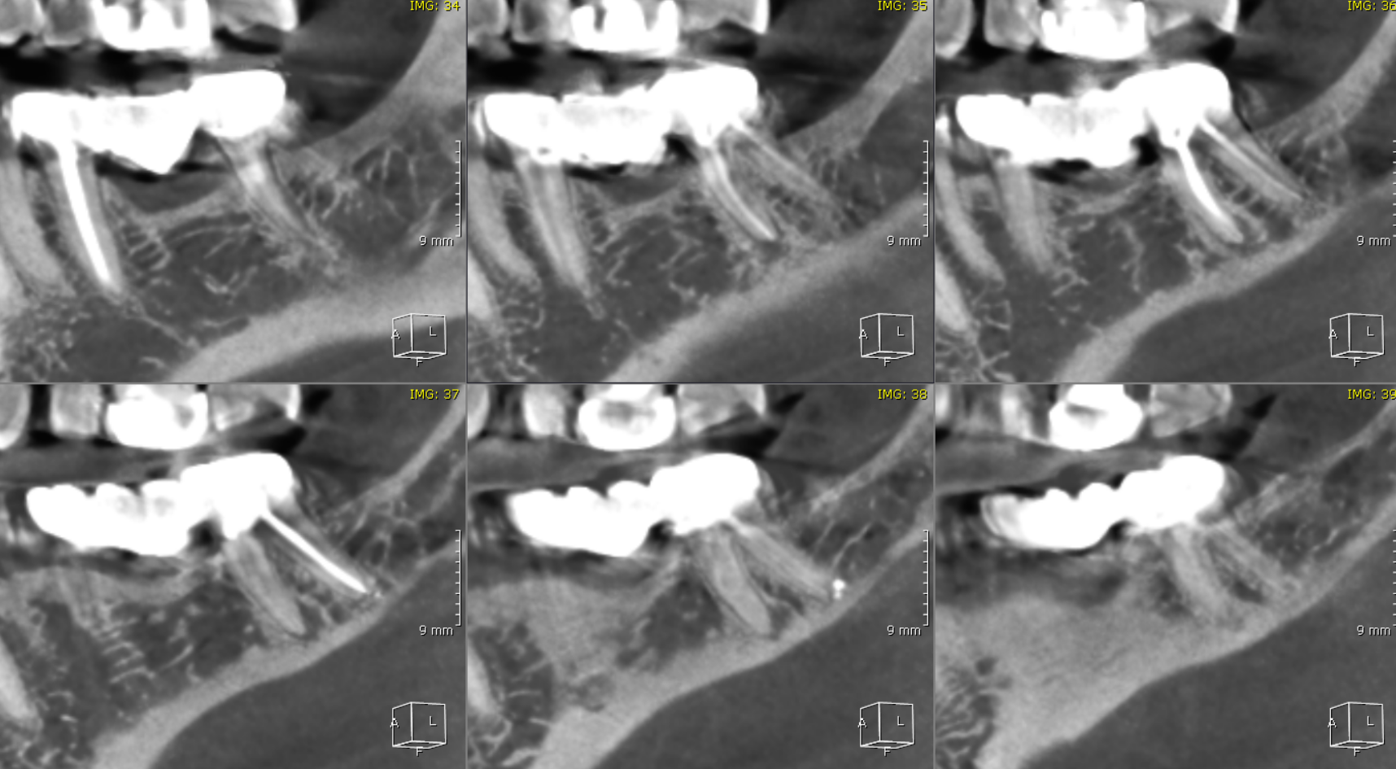
Retained periapical restorative material in relation to the distal root of 37 | 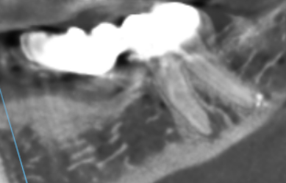

**** End of report ****

